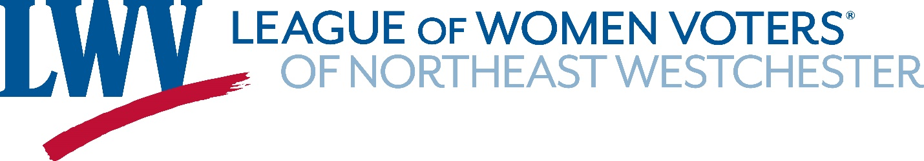

October 30, 2021
To Whom It May Concern:
Thank you for this opportunity to submit testimony. The League of Women Voters of North East Westchester (LWVNEW) covers the towns of Bedford, Lewisboro, Mount Kisco, North Salem, and Pound Ridge.
We at LWVNEW are concerned about communities of interest being split up. Four of the five towns in our territory are currently located in NYS Senate District 40; Bedford, however, is located in State Senate District 37, surrounded on three sides by SD 40. We appreciate that the delineation needs to occur somewhere but it seems ‘off’ that Bedford sits at the very northern end of SD 37, grouped with cities such as White Plains, Yonkers, and New Rochelle and towns such as Mamaroneck, Eastchester, and Rye. SD 37 snakes north into a long, skinny shape, which might be understandable if the purpose of this northward reach was to ‘grab’ a town similar to most of the others in the district. This, however, is not the case. Bedford actually has much more in common with the aforementioned towns in SD 40; in fact, Bedford is indeed grouped with Lewisboro, Mount Kisco, North Salem, and Pound Ridge in NYS Assembly District 93.
We also feel strongly that the IRC, as a bipartisan commission, should offer one map instead of the two competing maps currently being proposed. This is a time for clarity and dueling maps only muddy the waters. Many voters who rightfully expect to see good faith efforts from the IRC probably also expect disappointment and “more of the same.” The issuance of competing maps fosters confusion and reinforces feelings of distrust in government.
Offering clear, concise, fair maps should be the goal of the IRC. Grouping communities of interest and offering one bipartisan map are important steps to achieving this goal.
Thank you for your time.
Sincerely,
Lisa Pizzurro and Katherine Dering
Co-Presidents
League of Women Voters of North East Westchester

